Q. Explain Guided Media.
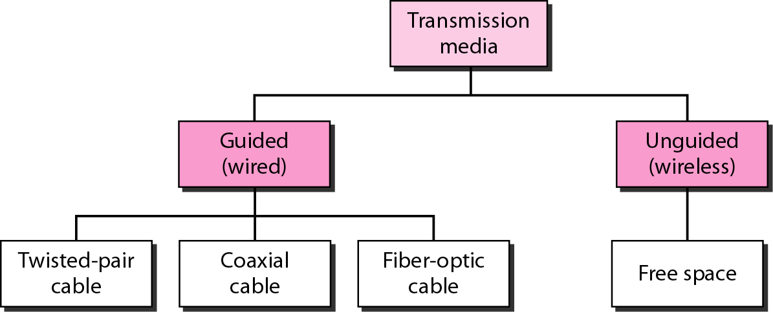
Guided media, which are those that provide a conduit from one device to another, include twisted-pair cable, coaxial cable, and fiber-optic cable. A signal traveling along any of these media is directed and contained by the physical limits of the medium. Twisted-pair and coaxial cable use metallic (copper) conductors that accept and transport signals in the form of electric current. Optical fiber is a cable that accepts and transports signals in the form of light.
Twisted-Pair Cable
A twisted pair consists of two conductors (normally copper), each with its own plastic insulation, twisted together. One of the wires is used to carry signals to the receiver, and the other is used only as a ground reference. The receiver uses the difference between the two. In addition to the signal sent by the sender on one of the wires, interference (noise) and crosstalk may affect both wires and create unwanted signals. If the two wires are parallel, the effect of these unwanted signals is not the same in both wires because they are at different locations relative to the noise or crosstalk sources (e.g., one is closer and the other is farther). This results in a difference at the receiver. By twisting the pairs, a balance is maintained. For example, suppose in one twist, one wire is closer to the noise source and the other is farther; in the next twist, the reverse is true. Twisting makes it probable that both wires are equally affected by external influences (noise or crosstalk). This means that the receiver, which calculates the difference between the two, receives no unwanted signals. The unwanted signals are mostly canceled out. From the above discussion, it is clear that the number of twists per unit of length (e.g., inch) has some effect on the quality of the cable.
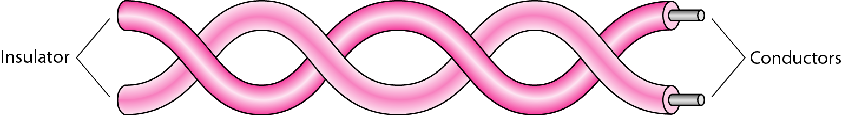
Fig: Twisted pair cable
The most common twisted-pair cable used in communications is referred to as unshielded twisted-pair (UTP). IBM has also produced a version of twisted-pair cable for its use called shielded twisted-pair (STP). STP cable has a metal foil or braided mesh covering that encases each pair of insulated conductors. Although metal casing improves the quality of cable by preventing the penetration of noise or crosstalk, it is bulkier and more expensive. Figure 7.4 shows the difference between UTP and STP. Our discussion focuses primarily on UTP because STP is seldom used outside of IBM.
The Electronic Industries Association (EIA) has developed standards to classify unshielded twisted-pair cable into seven categories. Categories are determined by cable quality, with 1 as the lowest and 7 as the highest. The most common UTP connector is RJ45 (RJ stands for registered jack),

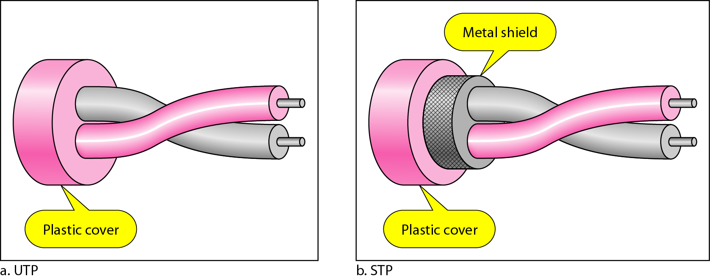
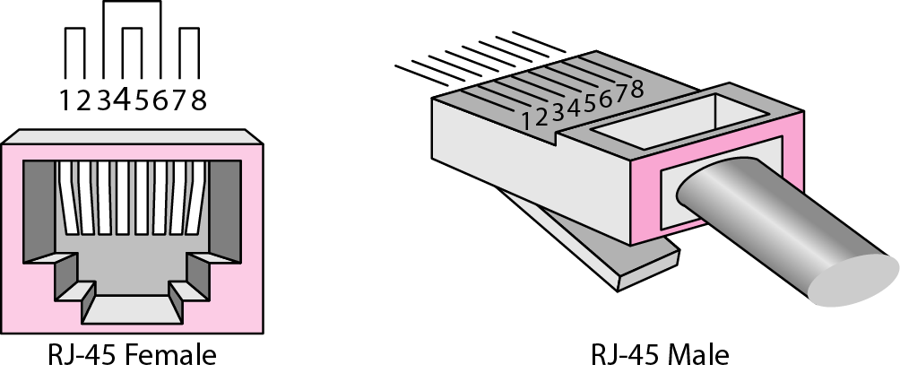

Fig: twisted pair connectors

Coaxial Cable
Coaxial cable (or coax) carries signals ofhigher frequency ranges than those in twistedpair cable, in part because the two media are constructed quite differently. Instead ofhaving two wires, coax has a central core conductor of solid or stranded wire (usually copper) enclosed in an insulating sheath, which is, in turn, encased in an outer conductor of metal foil, braid, or a combination of the two. The outer metallic wrapping serves both as a shield against noise and as the second conductor, which completes the circuit. This outer conductor is also enclosed in an insulating sheath, and the whole cable is protected by a plastic cover

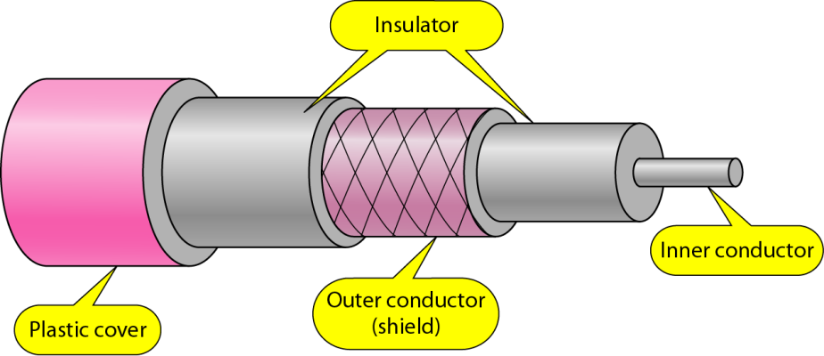
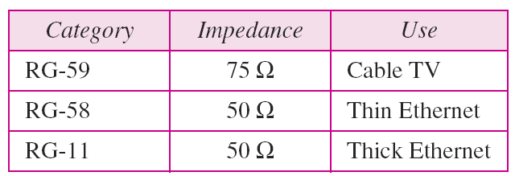
Coaxial Cable Connectors
To connect coaxial cable to devices, we need coaxial connectors. The most common type of connector used today is the Bayone-Neill-Concelman (BNe), connector. Figure 7.8 shows three popular types of these connectors: the BNC connector, the BNC T connector, and the BNC terminator. The BNC connector is used to connect the end of the cable to a device, such as a TV set.
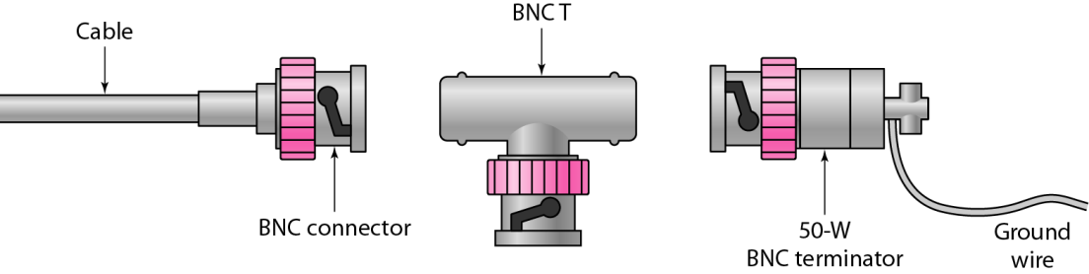
Fiber-Optic Cable
A fiber-optic cable is made of glass or plastic and transmits signals in the form of light. To understand optical fiber, we first need to explore several aspects of the nature of light. Light travels in a straight line as long as it is moving through a single uniform substance. If a ray of light traveling through one substance suddenly enters another substance (of a different density), the ray changes direction.
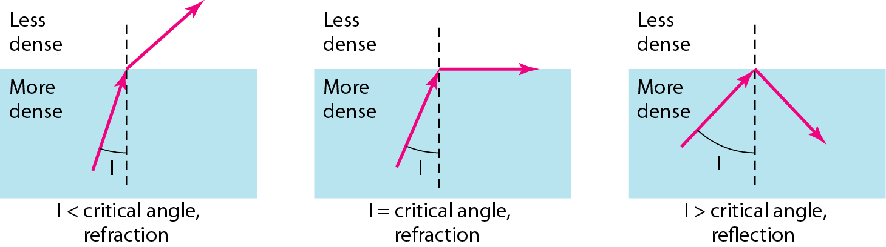
If the angle of incidence I (the angle the ray makes with the line perpendicular to the interface between the two substances) is less than the critical angle, the ray refracts and moves closer to the surface. If the angle of incidence is equal to the critical angle, the light bends along the interface. If the angle is greater than the critical angle, the ray reflects (makes a turn) and travels again in the denser substance. Note that the critical angle is a property of the substance, and its value differs from one substance to another. Optical fibers use reflection to guide light through a channel. A glass or plastic core is surrounded by a cladding of less dense glass or plastic. The difference in density of the two materials must be such that a beam of light moving through the core is reflected off the cladding instead of being refracted into it.
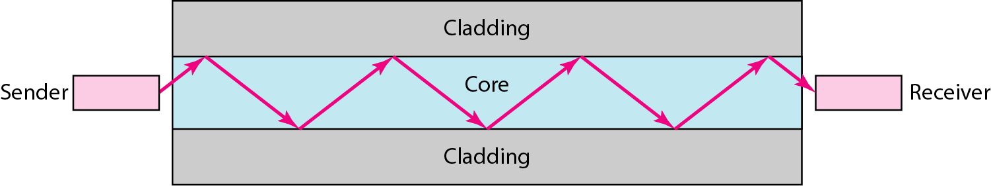
The outer jacket is made of either PVC or Teflon. Inside the jacket are Kevlar strands to strengthen the cable. Kevlar is a strong material used in the fabrication of bullet proof vests. Below the Kevlar is another plastic coating to cushion the fiber. The fiber is at the center of the cable, and it consists of cladding and core.
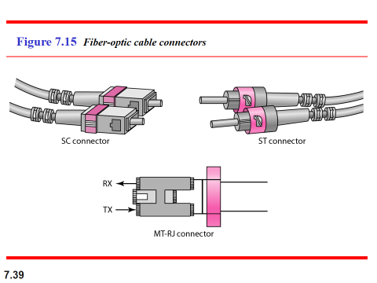
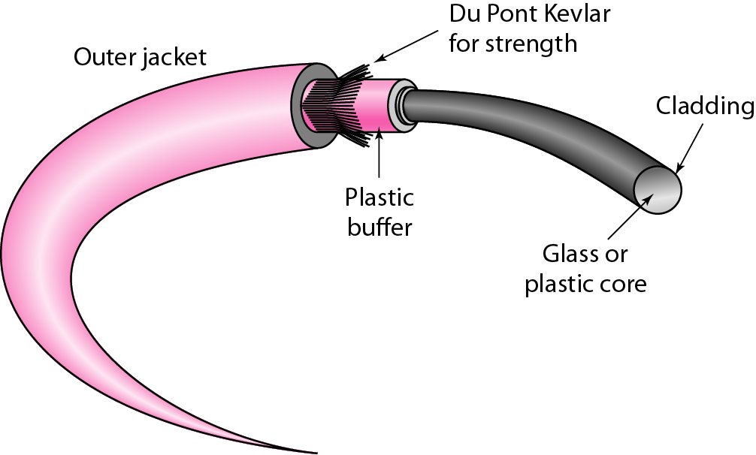

Q. Modes of Communication in Fiber Optics:

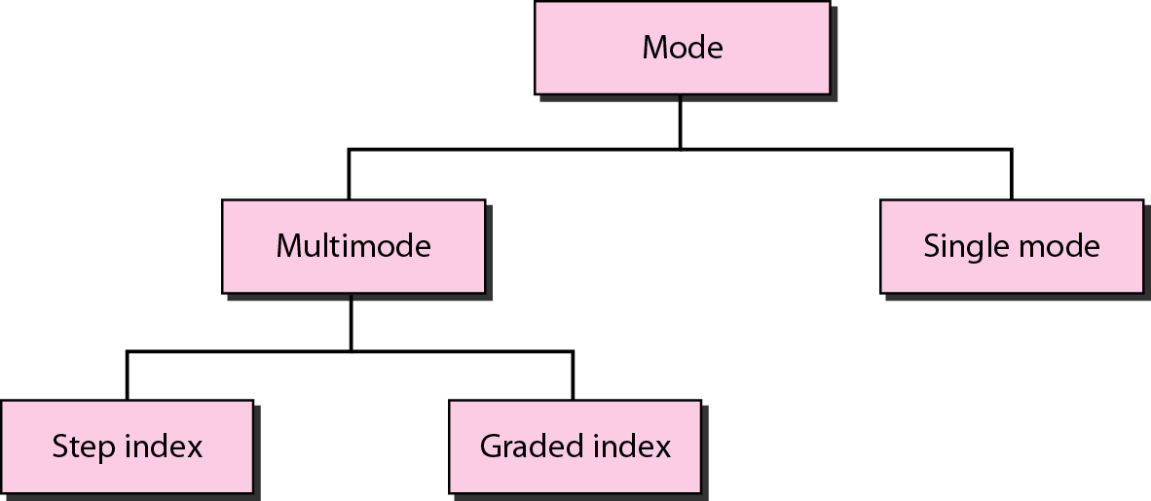
Figure: Propagation modes

A fiber-optic cable is made of glass or plastic and transmits signals in the form of light. Light travels in a straight line as long as it is moving through a single uniform substance. If a ray of light traveling through one substance suddenly enters another substance (of a different density), the ray changes direction. Optical fibers use reflection to guide light through a channel. A glass or plastic core is surrounded by a cladding of less dense glass or plastic. The difference in density of the two materials must be such that a beam of light moving through the core is reflected off the cladding instead of being refracted into it.

Propagation Modes
Current technology supports two modes (multimode and single mode) for propagating light along optical channels, each requiring fiber with different physical characteristics. Multimode can be implemented in two forms: step-index or graded-index as shown below:

Multimode: Multimode is so named because multiple beams from a light source move through the core in different paths. How these beams move within the cable depends on the structure of the core, as shown in figure given below.

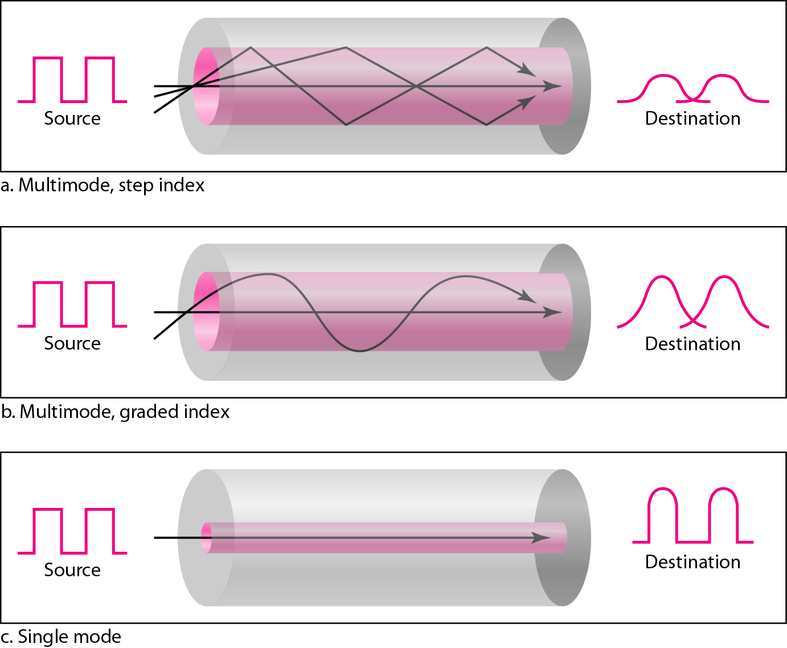
Figure: Modes

In multimode step-index fiber, the density of the core remains constant from the center to the edges. A beam of light moves through this constant density in a straight line until it reaches the interface of the core and the cladding. At the interface, there is an abrupt change due to a lower density; this alters the angle of the beam's motion. The term step index refers to the suddenness of this change, which contributes to the distortion of the signal as it passes through the fiber.
A second type of fiber, called multimode graded-index fiber, decreases this distortion of the signal through the cable. The word index here refers to the index of refraction. As we saw above, the index of refraction is related to density. A graded-index fiber, therefore, is one with varying densities. Density is highest at the center of the core and decreases gradually to its lowest at the edge. Above figure shows the impact of this variable density on the propagation of light beams.
Single-Mode: Single-mode uses step-index fiber and a highly focused source of light that limits beams to a small range of angles, all close to the horizontal. The single- mode fiber itself is manufactured with a much smaller diameter than that of multimode fiber, and with substantially lower density (index of refraction). The decrease in density results in a critical angle that is close enough to 90° to make the propagation of beams almost horizontal. In this case, propagation of different beams is almost identical, and delays are negligible. All the beams arrive at the destination "together" and can be recombined with little distortion to the signal as shown in the above figure.

Q. Explain Advantages and Disadvantages of Optical Fiber
Advantages:
Fiber-optic cable has several advantages over metallic cable (twisted - pair or coaxial).
- Higher bandwidth: Fiber-optic cable can support dramatically higher bandwidths (and hence data rates) than either twisted-pair or coaxial cable. Currently, data rates and bandwidth utilization over fiber-optic cable are limited not by the medium but by the signal generation and reception technology available.
- Less signal attenuation: Fiber-optic transmission distance is significantly greater than that of other guided media. A signal can run for 50 km without requiring regeneration. We need repeaters every 5 km for coaxial or twisted-pair cable.
- Immunity to electromagnetic interference: Electromagnetic noise cannot affect fiber-optic cables.
- Resistance to corrosive materials: Glass is more resistant to corrosive materials than copper.
- Light weight: Fiber-optic cables are much lighter than copper cables.
- Greater immunity to tapping: Fiber-optic cables are more immune to tapping than copper cables. Copper cables create antenna effects that can easily be tapped.
Disadvantages: There are some disadvantages in the use of optical fiber.
- Installation and maintenance: Fiber-optic cable is a relatively new technology. Its installation and maintenance require expertise that is not yet available everywhere.
- Unidirectional light propagation: Propagation of light is unidirectional. If we need bidirectional communication, two fibers are needed.
- Cost: The cable and the interfaces are relatively more expensive than those of other guided media. If the demand for bandwidth is not high, often the use of optical fiber cannot be justified.

Q. Explain Unguided Media.

Unguided media transport electromagnetic waves without using a physical conductor. This type of communication is often referred to as wireless communication. Signals are normally broadcast through free space and thus are available to anyone who has a device capable of receiving them.
Unguided signals can travel from the source to destination in several ways: ground propagation, sky propagation, and line-of-sight propagation.
In ground propagation, radio waves travel through the lowest portion of the atmosphere, hugging the earth. These low-frequency signals emanate in all directions from the transmitting antenna and follow the curvature of the planet. Distance depends on the amount of power in the signal: The greater the power, the greater the distance. In sky propagation, higher-frequency radio waves radiate upward into the ionosphere (the layer of atmosphere where particles exist as ions) where they are reflected back to earth. This type of transmission allows for greater distances with lower output power. In line-or-sight propagation, very high-frequency signals are transmitted in straight lines directly from antenna to antenna. Antennas must be directional, facing each other,
and either tall enough or close enough together not to be affected by the curvature of the earth. Line-of-sight propagation is tricky because radio transmissions cannot be completely focused. The section of the electromagnetic spectrum defined as radio waves and microwaves is divided into eight ranges, called bands, each regulated by government authorities. These bands are rated from very low frequency (VLF) to extremely high frequency (EHF).

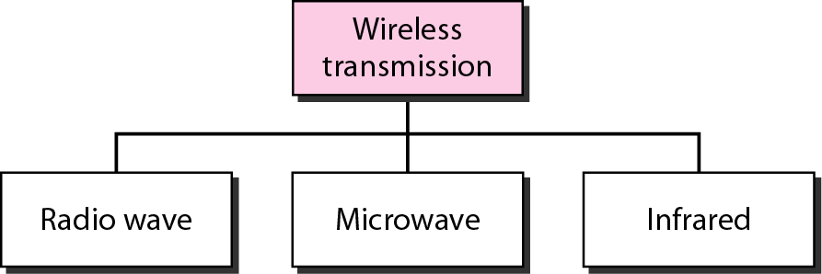
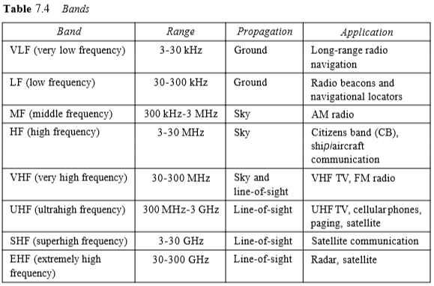
Radio Waves
Although there is no clear-cut demarcation between radio waves and microwaves, electromagnetic waves ranging in frequencies between 3 kHz and 1 GHz are normally called radio waves; waves ranging in frequencies between 1 and 300 GHz are called microwaves. However, the behavior of the waves, rather than the frequencies, is a better criterion for classification. Radio waves, for the most part, are omnidirectional. When an antenna transmits radio waves, they are propagated in all directions. This means that the sending and receiving antennas do not have to be aligned. A sending antenna sends waves that can be received by any receiving antenna. The omnidirectional property has a disadvantage, too. The radio waves transmitted by one antenna are susceptible to interference by another antenna that may send signals using the same frequency or band. Radio waves, particularly those waves that propagate in the sky mode, can travel long distances. This makes radio waves a good candidate for long-distance broadcasting such as AM radio.
Omnidirectional Antenna
Radio waves use omnidirectional antennas that send out signals in all directions. Based on the wavelength, strength, and the purpose of transmission, we can have several types of antennas. Figure 7.20 shows an omnidirectional antenna.
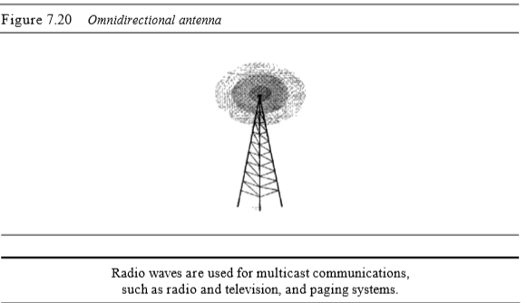
Microwaves
Electromagnetic waves having frequencies between I and 300 GHz are called microwaves. Microwaves are unidirectional. When an antenna transmits microwave waves, they can be narrowly focused. This means that the sending and receiving antennas need to be aligned. The unidirectional property has an obvious advantage. A pair of antennas can be aligned without interfering with another pair of aligned antennas. The following describes some characteristics of microwave propagation: o Microwave propagation is line-of-sight. Since the towers with the mounted antennas need to be in direct sight of each other, towers that are far apart need to be very tall. The curvature of the earth as well as other blocking obstacles do not allow two short towers to communicate by using microwaves. Repeaters are often needed for long distance communication. o Very high-frequency microwaves cannot penetrate walls. This characteristic can be a disadvantage if receivers are inside buildings. o The microwave band is relatively wide, almost 299 GHz. Therefore wider sub bands can be assigned, and a high data rate is possible o Use of certain portions of the band requires permission from authorities.
Unidirectional Antenna
Microwaves need unidirectional antennas that send out signals in one direction. Two types of antennas are used for microwave communications:
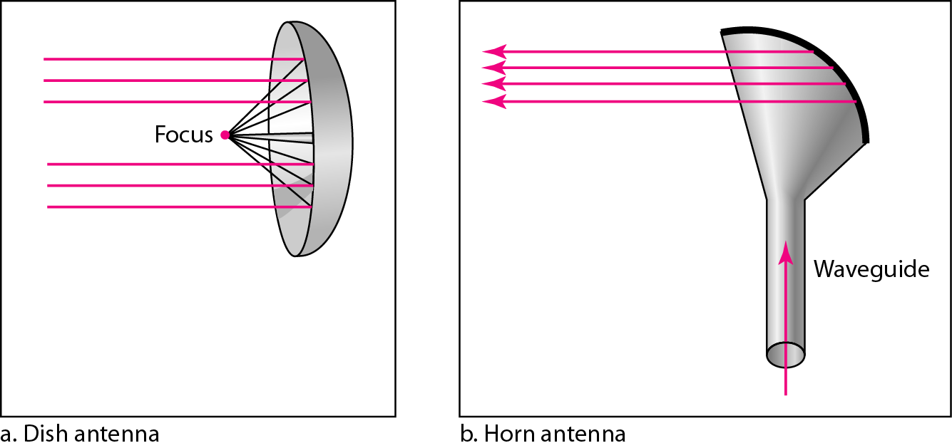
Infrared
Infrared waves, with frequencies from 300 GHz to 400 THz (wavelengths from 1 mm to 770 nm), can be used for short-range communication. Infrared waves, having high frequencies, cannot penetrate walls. This advantageous characteristic prevents interference between one system and another; a short-range communication system in one room cannot be affected by another system in the next room. When we use our infrared remote control, we do not interfere with the use of the remote by our neighbors. However, this same characteristic makes infrared signals useless for long-range communication. In addition, we cannot use infrared waves outside a building because the sun's rays contain infrared waves that can interfere with the communication.
ANALOG-TO-DIGITAL CONVERSION:
- Pulse Code Modulation (PCM)
The most common technique to change an analog signal to digital data (digitization) is called pulse code modulation (PCM). A PCM encoder has three processes:
- Sampling
- Quantizing
- Encoding
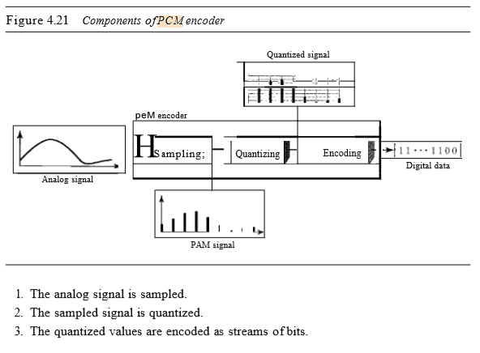
Sampling:
The first step in PCM is sampling. The analog signal is sampled every Ts s, where Ts is the sample interval or period. The inverse of the sampling interval is called the sampling rate or sampling frequency and denoted by is, where is = IITs ' There are three sampling methods-ideal, natural, and flat-top.
In ideal sampling, pulses from the analog signal are sampled. This is an ideal sampling method and cannot be easily implemented. In natural sampling, a high-speed switch is turned on for only the small period of time when the sampling occurs. The result is a sequence of samples that retains the shape of the analog signal. The most common sampling method, called sample and hold, however, creates flat-top samples by using a circuit.
The sampling process is sometimes referred to as pulse amplitude modulation (PAM). We need to remember, however, that the result is still an analog signal with non integral values.
According to the Nyquist theorem, to reproduce the original analog signal, one necessary condition is that the sampling rate be at least twice the highest frequency in the original signal.
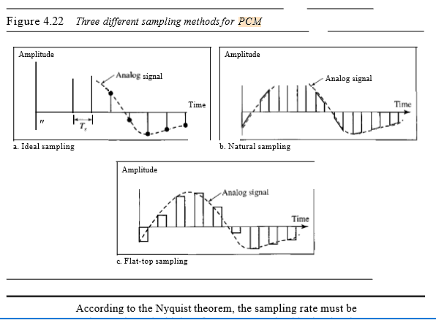
Quantization
The result of sampling is a series of pulses with amplitude values between the maximum and minimum amplitudes of the signal. The set of amplitudes can be infinite with non integral values between the two limits. These values cannot be used in the encoding process. The following are the steps in quantization:
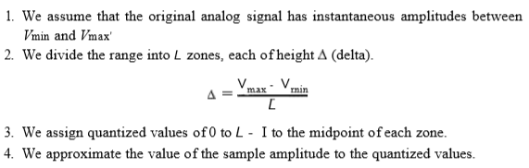
As a simple example, assume that we have a sampled signal and the sample amplitudes are between -20 and +20 V. We decide to have eight levels (L = 8). This means that ~ =5 V.
Encoding
The last step in PCM is encoding. After each sample is quantized and the number of bits per sample is decided, each sample can be changed to an llb-bit code word. In Figure 4.26 the encoded words are shown in the last row. A quantization code of 2 is encoded as 010; 5 is encoded as 101; and so on. Note that the number of bits for each sample is determined from the number of quantization levels. If the number of quantization levels is L, the number of bits is llb =log2 L. In our example L is 8 and llb is therefore 3. The bit rate can be found from the formula.
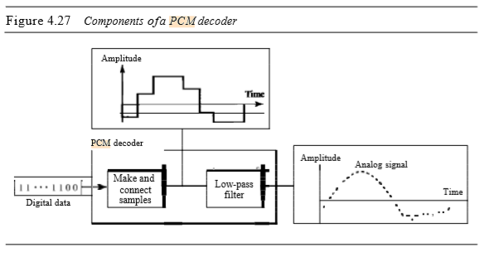
PCM decoder
The decoder first uses circuitry to convert the code words into a pulse that holds the amplitude until the next pulse. After the staircase signal is completed, it is passed through a low-pass filter to smooth the staircase signal into an analog signal. The filter has the same cutoff frequency as the original signal at the sender. If the signal has been sampled at (or greater than) the Nyquist sampling rate and if there are enough quantization levels, the original signal will be recreated. Note that the maximum and minimum values of the original signal can be achieved by using amplification. Figure 4.27 shows the simplified process.
VIRTUAL LANs
A virtual local area network (VLAN) can be defined as a local area network configured by software, not by physical wiring.
Following figure shows a switched LAN in an engineering firm in which 10 stations are grouped into three LANs that are connected by a switch. The first four engineers work together as the first group, the next three engineers work together as the second group, and the last three engineers work together as the third group. The LAN is configured to allow this arrangement.
2.Delta Modulation (DM):
PCM is a very complex technique. Other techniques have been developed to reduce the complexity of PCM. The simplest is delta modulation. PCM finds the value of the signal amplitude for each sample; DM finds the change from the previous sample. Figure 4.28 shows the process. Note that there are no code words here; bits are sent one after another.
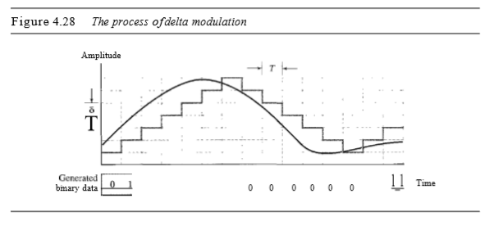
Modulator:
The modulator is used at the sender site to create a stream of bits from an analog signal. The process records the small positive or negative changes, called delta O. If the delta is positive, the process records a I; ifit is negative, the process records a O. However, the process needs a base against which the analog signal is compared. The modulator builds a second signal that resembles a staircase. Finding the change is then reduced to comparing the input signal with the gradually made staircase signal. Figure 4.29 shows a diagram of the process.
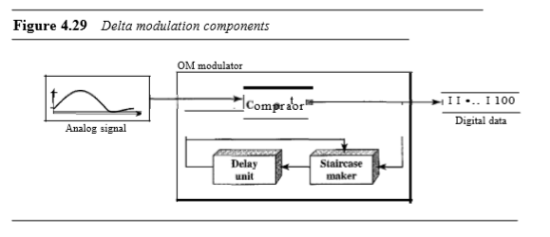
The modulator, at each sampling interval, compares the value of the analog signal with the last value of the staircase signal. If the amplitude of the analog signal is larger, the next bit in the digital data is 1; otherwise, it is O. The output of the comparator, however, also makes the staircase itself. If the next bit is I, the staircase maker moves the last point of the staircase signal 0 up; it the next bit is 0, it moves it 0 down. Note that we need a delay unit to hold the staircase function for a period between two comparisons.
Demodulator:
The demodulator takes the digital data and, using the staircase maker and the delay unit, creates the analog signal. The created analog signal, however, needs to pass through a low-pass filter for smoothing. Figure 4.30 shows the schematic diagram.
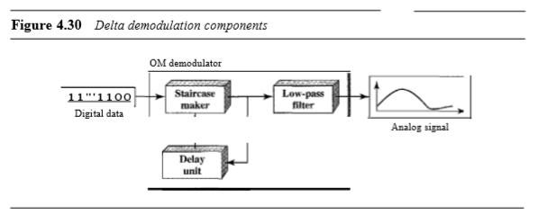
A better performance can be achieved if the value of 0 is not fixed. In adaptive delta modulation, the value of 0 changes according to the amplitude of the analog signal.

Q. Explain types of multiplexing
Whenever the bandwidth of a medium linking two devices is greater than the bandwidth needs of the devices, the link can be shared. Multiplexing is the set of techniques that allows the simultaneous transmission of multiple signals across a single data link. As data and telecommunications use increases, so does traffic. We can accommodate this increase by continuing to add individual links each time a new channel is needed; or we can install higher-bandwidth links and use each to carry multiple signals.
In a multiplexed system, n lines share the bandwidth of one link. Figure 6.1 shows the basic format of a multiplexed system. The lines on the left direct their transmission streams to a multiplexer (MUX), which combines them into a single stream (many-to-one). At the receiving end, that stream is fed into a demultiplexer (DEMUX), which separates the stream back into its component transmissions (one-to-many) and directs them to their corresponding lines. In the figure, the word link refers to the physical path. The word channel refers to the portion of a link that carries a transmission between a given pair of lines. One link can have many (n) channels.
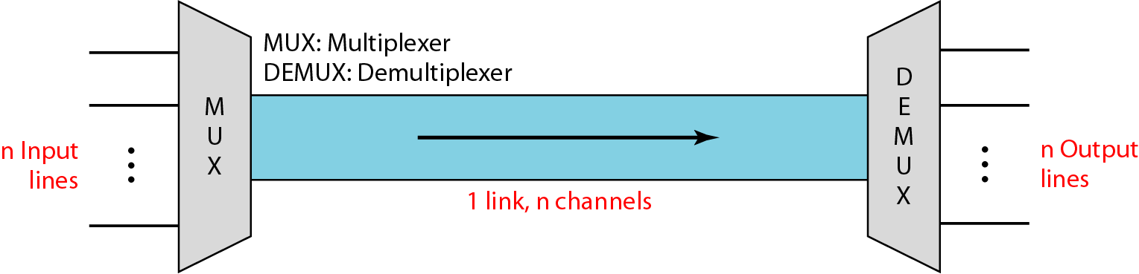
There are three basic multiplexing techniques: frequency-division multiplexing, wavelength-division multiplexing, and time-division multiplexing. The first two are techniques designed for analog signals, the third, for digital signals.
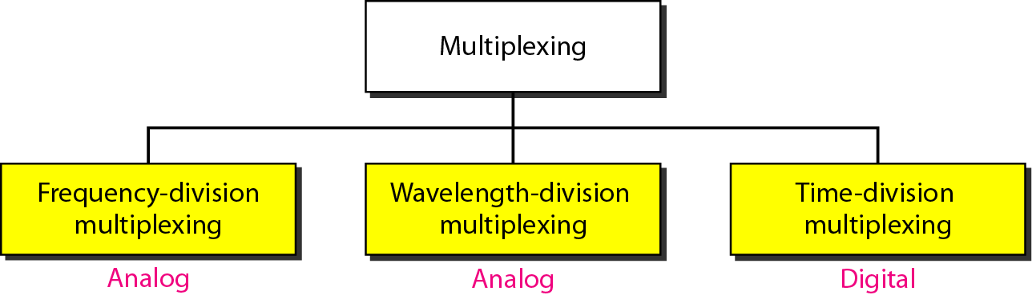
Frequency-Division Multiplexing
Frequency-division multiplexing (FDM) is an analog technique that can be applied when the bandwidth of a link (in hertz) is greater than the combined bandwidths of the signals to be transmitted. In FOM, signals generated by each sending device modulate different carrier frequencies. These modulated signals are then combined into a single composite signal that can be transported by the link. Carrier frequencies are separated by sufficient bandwidth to accommodate the modulated signal. These bandwidth ranges are the channels through which the various signals travel. Channels can be separated by strips of unused bandwidth-guard bands-to prevent signals from overlapping. In addition, carrier frequencies must not interfere with the original data frequencies. Figure 6.3 gives a conceptual view of FDM. In this illustration, the transmission path is divided into three parts, each representing a channel that carries one transmission.
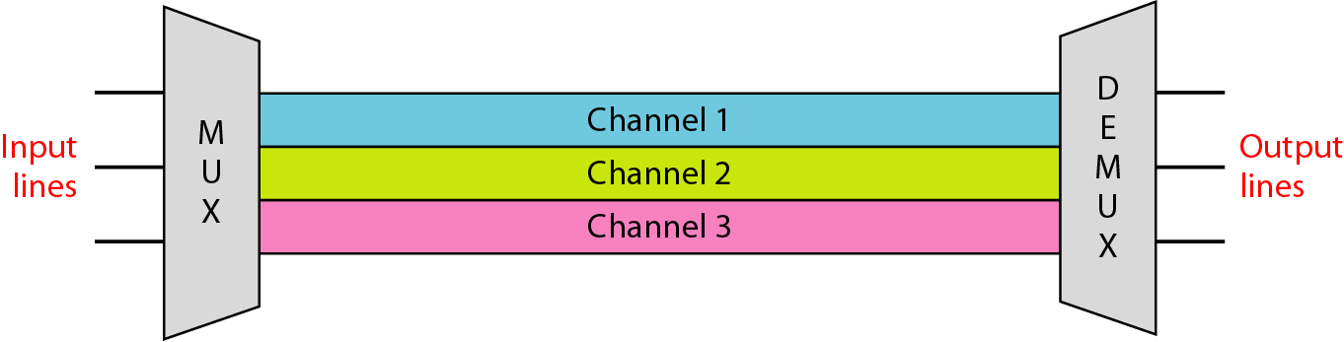
We consider FDM to be an analog multiplexing technique; however, this does not mean that FDM cannot be used to combine sources sending digital signals. A digital signal can be converted to an analog signal (with the techniques discussed in Chapter 5) before FDM is used to multiplex them.
NOTE: FDM is an analog multiplexing technique that combines analog signals.
Wavelength-Division Multiplexing
Wavelength-division multiplexing (WDM) is designed to use the high-data-rate capability of fiber-optic cable. The optical fiber data rate is higher than the data rate of metallic transmission cable. Using a fiber-optic cable for one single line wastes the available bandwidth. Multiplexing allows us to combine several lines into one.
WDM is conceptually the same as FDM, except that the multiplexing and demultiplexing involve optical signals transmitted through fiber-optic channels. The idea is the same: We are combining different signals of different frequencies. The difference is that the frequencies are very high.
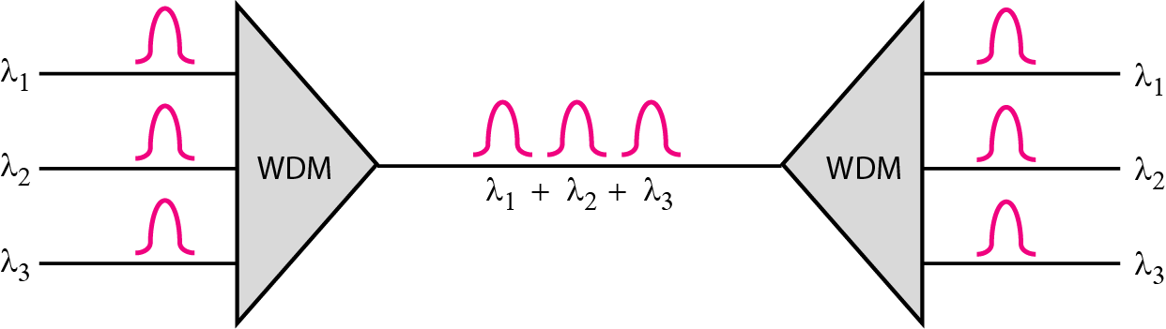
Although WDM technology is very complex, the basic idea is very simple. We want to combine multiple light sources into one single light at the multiplexer and do the reverse at the demultiplexer. The combining and splitting of light sources are easily handled by a prism. Recall from basic physics that a prism bends a beam of light based on the angle of incidence and the frequency. Using this technique, a multiplexer can be made to combine several input beams of light, each containing a narrow band of frequencies, into one output beam of a wider band of frequencies. A demultiplexer can also be made to reverse the process.
One application of WDM is the SONET network in which multiple optical fiber lines are multiplexed and demultiplexed. We discuss SONET in Chapter 17. A new method, called dense WDM (DWDM), can multiplex a very large number of channels by spacing channels very close to one another. It achieves even greater efficiency.
Synchronous Time-Division Multiplexing
Time-division multiplexing (TDM) is a digital process that allows several connections to share the high bandwidth of a line Instead of sharing a portion of the bandwidth as in FDM, time is shared. Each connection occupies a portion of time in the link. Figure 6.12 gives a conceptual view of TDM. Note that the same link is used as in FDM; here, however, the link is shown sectioned by time rather than by frequency. In the figure, portions of signals 1,2,3, and 4 occupy the link sequentially.
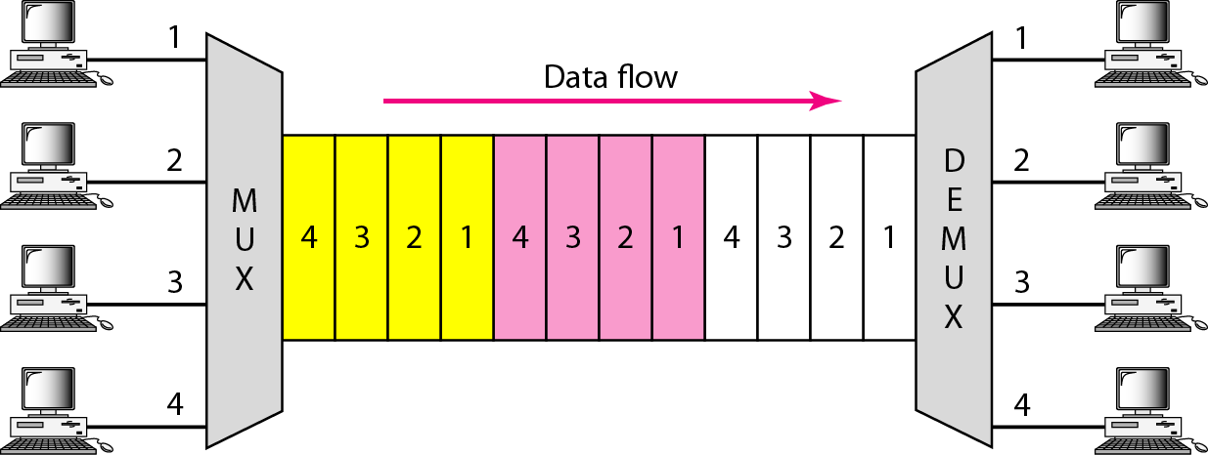
This means that all the data in a message from source 1 always go to one specific destination, be it 1, 2, 3, or 4. The delivery is fixed and unvarying, unlike switching. We also need to remember that TDM is, in principle, a digital multiplexing technique. Digital data from different sources are combined into one timeshared link. However, this does not mean that the sources cannot produce analog data; analog data can be sampled, changed to digital data, and then multiplexed by using TDM.
TDM is a digital multiplexing technique for combining several low-rate channels into one high-rate one. We can divide TDM into two different schemes: synchronous and statistical. We first discuss synchronous TDM and then show how statistical TDM differs. In synchronous TDM, each input connection has an allotment in the output even if it is not sending data.

Q. Explain Switching with its types.
A network is a set of connected devices. Whenever we have multiple devices, we have the problem of how to connect them to make one-to-one communication possible. One solution is to make a point-to-point connection between each pair of devices (a mesh topology) or between a central device and every other device (a star topology). These methods, however, are impractical and wasteful when applied to very large networks. The number and length of the links require too much infrastructure to be cost-efficient, and the majority of those links would be idle most of the time. Other topologies employing multipoint connections, such as a bus, are ruled out because the distances between devices and the total number of devices increase beyond the capacities of the media and equipment.
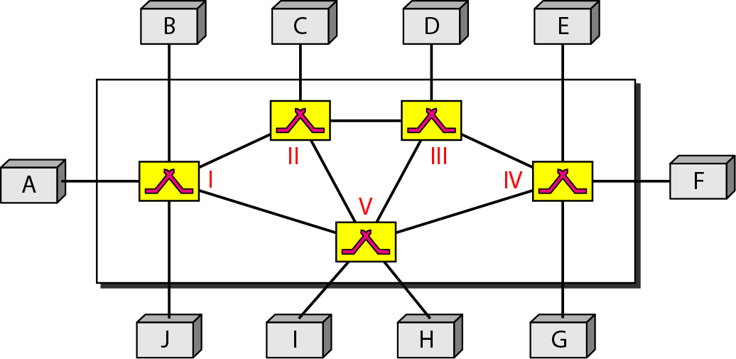

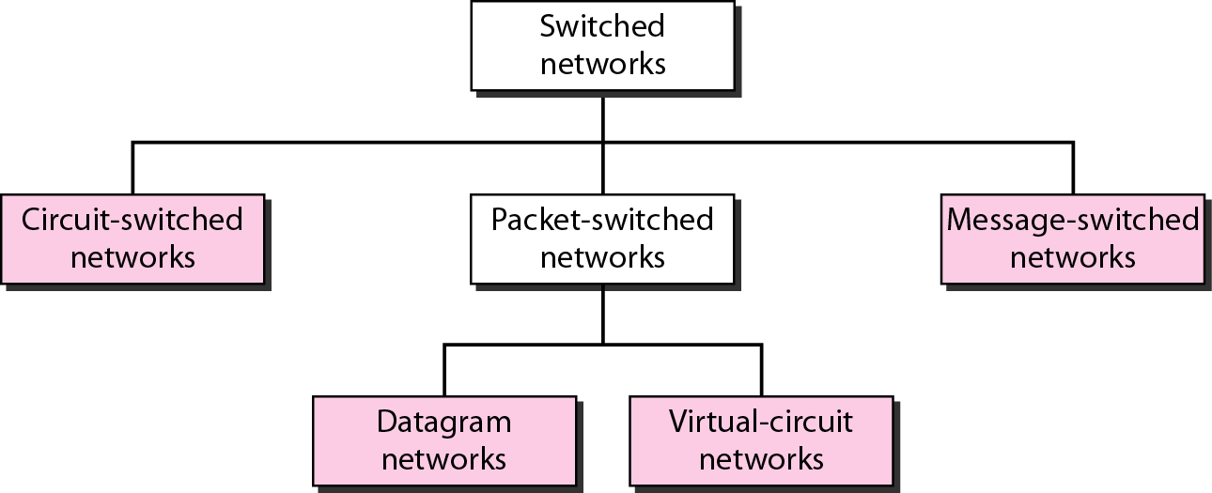
Circuit-switched networks
A circuit-switched network consists of a set of switches connected by physical links. A connection between two stations is a dedicated path made of one or more links. However, each connection uses only one dedicated channel on each link. Each link is normally divided into n channels by using FDM or TDM, A circuit-switched network is made of a set of switches connected by physical links, in which each link is divided into ‘n’ channels.
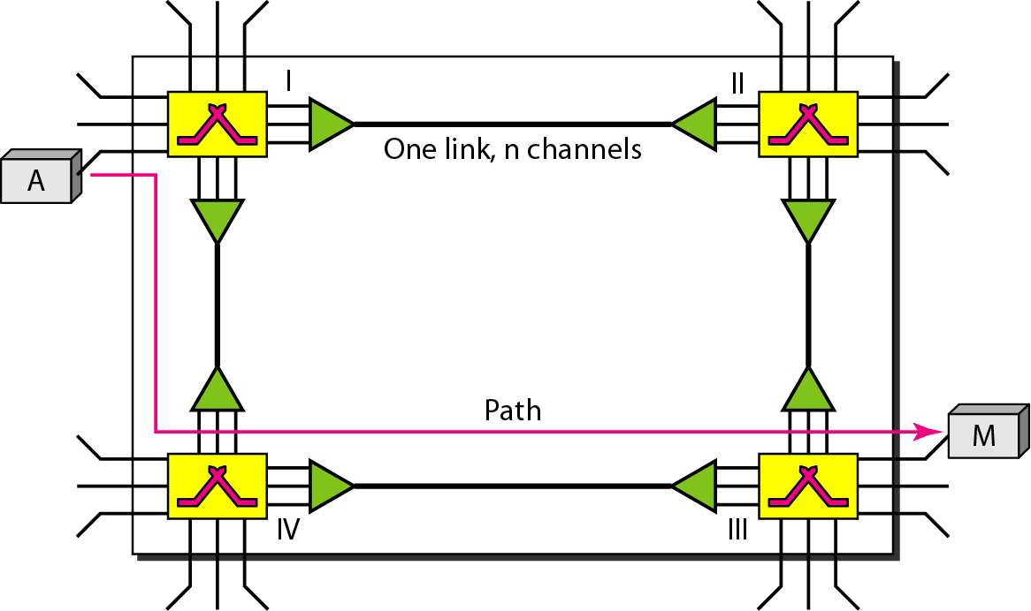
In circuit switching, the resources need to be reserved during the setup phase; the resources remain dedicated for the entire duration of data transfer until the teardown phase.
Three Phases
The actual communication in a circuit-switched network requires three phases: connection setup, data transfer, and connection teardown.
Setup Phase
Before the two parties (or multiple parties in a conference call) can communicate, a dedicated circuit (combination of channels in links) needs to be established. The end systems are normally connected through dedicated lines to the switches, so connection setup means creating dedicated channels between the switches. For example, in Figure 8.3, when system A needs to connect to system M, it sends a setup request that includes the address of system M, to switch I. Switch I finds a channel between itself and switch IV that can be dedicated for this purpose. Switch I then sends the request to switch IV, which finds a dedicated channel between itself and switch III. Switch III informs system M of system A's intention at this time. In the next step to making a connection, an acknowledgment from system M needs to be sent in the opposite direction to system A. Only after system A receives this acknowledgment is the connection established. Note that end-to-end addressing is required for creating a connection between the two end systems. These can be, for example, the addresses of the computers assigned by the administrator in a TDM network, or telephone numbers in an FDM network.
Data Transfer Phase
After the establishment of the dedicated circuit (channels), the two parties can transfer data.
Teardown Phase
When one of the parties needs to disconnect, a signal is sent to each switch to release the resources.
Delay
Although a circuit-switched network normally has low efficiency, the delay in this type of network is minimal. During data transfer the data are not delayed at each switch; the resources are allocated for the duration of the connection.
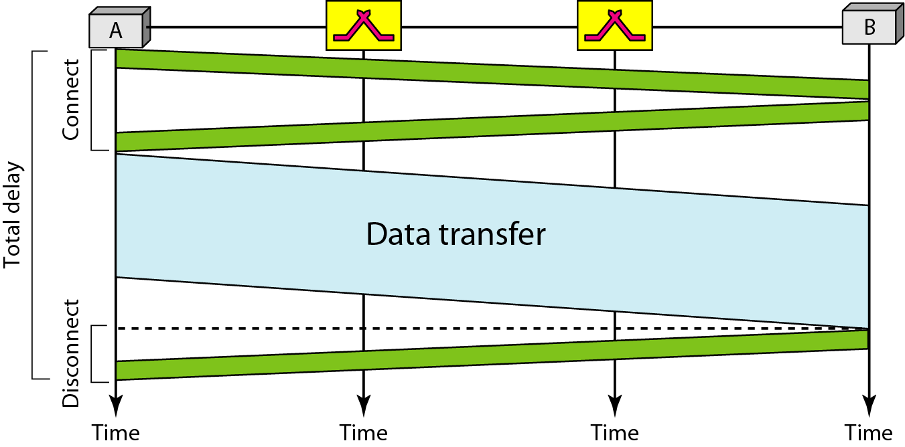

Datagram networks
In data communications, we need to send messages from one end system to another. If the message is going to pass through a packet-switched network, it needs to be divided into packets of fixed or variable size. The size of the packet is determined by the network and the governing protocol. In packet switching, there is no resource allocation for a packet.
Resources are allocated on demand. The allocation is done on a firstcome, first-served basis. When a switch receives a packet, no matter what is the source or destination, the packet must wait if there are other packets being processed. As with other systems in our daily life, this lack ofreservation may create delay.
In a packet-switched network, there is no resource reservation; resources are allocated on demand.
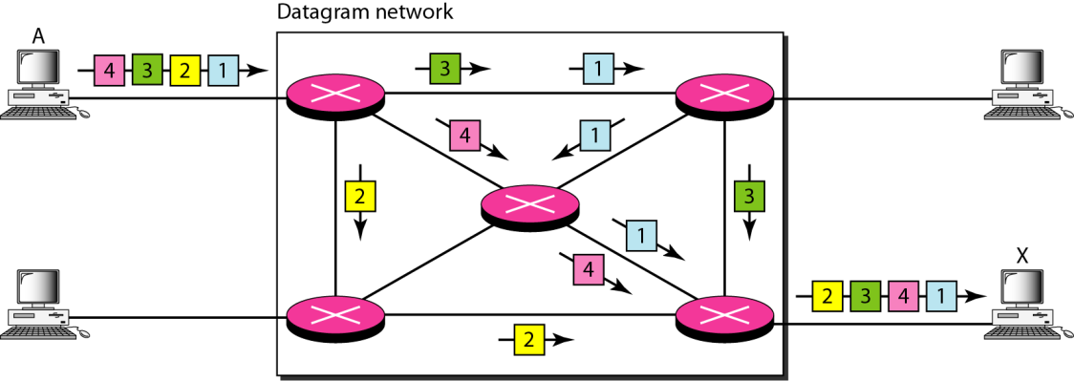
Routing Table
Ifthere are no setup or teardown phases, how are the packets routed to their destinations in a datagram network? In this type ofnetwork, each switch (or packet switch) has a routing table which is based on the destination address. The routing tables are dynamic and are updated periodically. The destination addresses and the corresponding forwarding output ports are recorded in the tables. This is different from the table of a circuitswitched network in which each entry is created when the setup phase is completed and deleted when the teardown phase is over. Figure 8.8 shows the routing table for a switch.
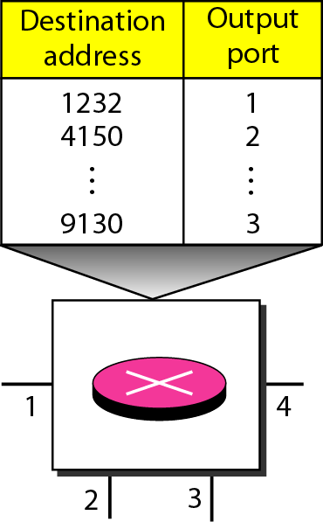
The destination address in the header ofa packet in a datagram network remains the same during the entirejourneyofthe packet.

Virtual-circuit networks
A virtual-circuit network is a cross between a circuit-switched network and a datagram network. Ithas some characteristics of both.
- As in a circuit-switched network, there are setup and teardown phases in addition to the data transfer phase.
- Resources can be allocated during the setup phase, as in a circuit-switched network, or on demand, as in a datagram network.
- As in a datagram network, data are packetized and each packet carries an address in the header. However, the address in the header has local jurisdiction (it defines what should be the next switch and the channel on which the packet is being canied), not end-to-end jurisdiction. The reader may ask how the intermediate switches know where to send the packet if there is no final destination address carried by a packet. The answer will be clear when we discuss virtual-circuit identifiers in the next section.
- As in a circuit-switched network, all packets follow the same path established during the connection.
- A virtual-circuit network is normally implemented in the data link layer, while a circuit-switched network is implemented in the physical layer and a datagram network in the network layer. But this may change in the future.
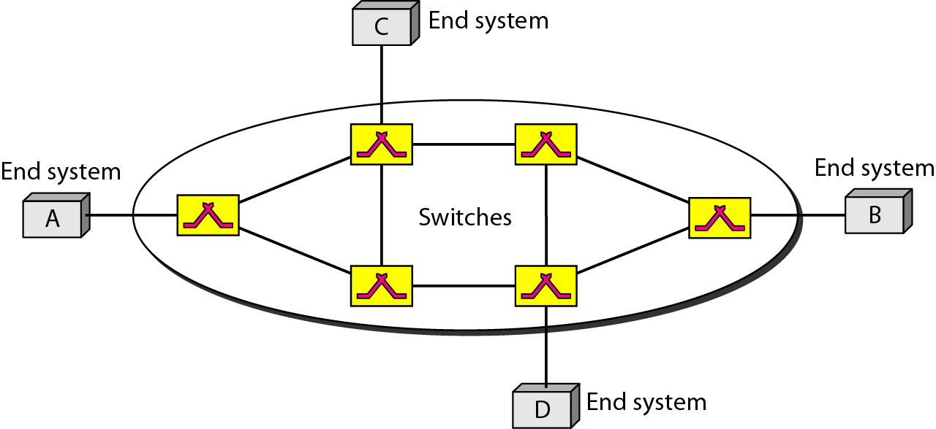
Addressing
In a virtual-circuit network, two types of addressing are involved: global and local (virtual-circuit identifier).
Global Addressing
A source or a destination needs to have a global address-an address that can be unique in the scope of the network or internationally if the network is part of an international network. However, we will see that a global address in virtual-circuit networks is used only to create a virtual-circuit identifier, as discussed next.
Three Phases
As in a circuit-switched network, a source and destination need to go through three phases in a virtual-circuit network: setup, data transfer, and teardown. In the setup phase, the source and destination use their global addresses to help switches make table entries for the connection. In the teardown phase, the source and destination inform the switches to delete the corresponding entry. Data transfer occurs between these two phases. We first discuss the data transfer phase, which is more straightforward; we then talk about the setup and teardown phases.
Data Transfer Phase
To transfer a frame from a source to its destination, all switches need to have a table entry for this virtual circuit. The table, in its simplest form, has four columns. This means that the switch holds four pieces of information for each virtual circuit that is already set up.
Setup Phase
In the setup phase, a switch creates an entry for a virtual circuit. For example, suppose source A needs to create a virtual circuit to B. Two steps are required: the setup request and the acknowledgment.
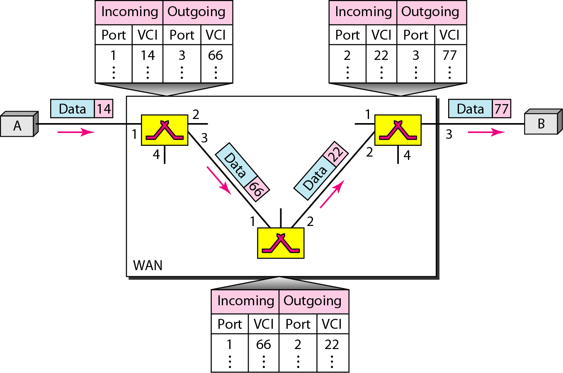
Teardown Phase
In this phase, source A, after sending all frames to B, sends a special frame called a teardown request. Destination B responds with a teardown confirmation frame. All switches delete the corresponding entry from their tables.

